POST VIBE MAGNETOMETER DATA

SELF TEST

|  |  |  |  |
| --- | --- | --- | --- |
|  | Non-Vibe 430 | Post Vibe 430 | Post Vibe 432 |
| Raw X | 477 | 499 | Reasonable Data |
| Raw Y | 435 | 442 | Reasonable Data |
| Raw Z | 529 | 527 | Reasonable Data |

AARDVARK DATA

|  |  |  |  |
| --- | --- | --- | --- |
|  | Non-Vibe 430 | Post Vibe 430 | Post Vibe 432 |
| Raw X | 150 | 181 | 110 |
| Raw Y | -170 | -521 | -282 |
| Raw Z | -660 | -40 | -743 |

Reaction to changing board’s orientation:

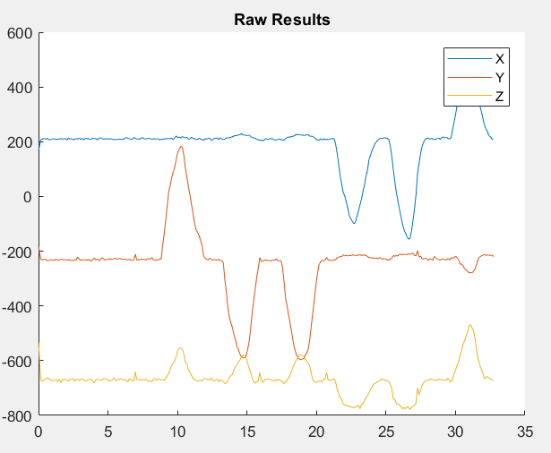

Non Vibe 430

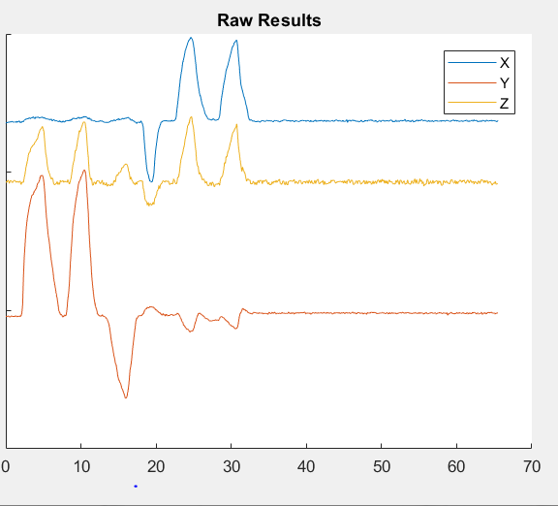

Post Vibe 432

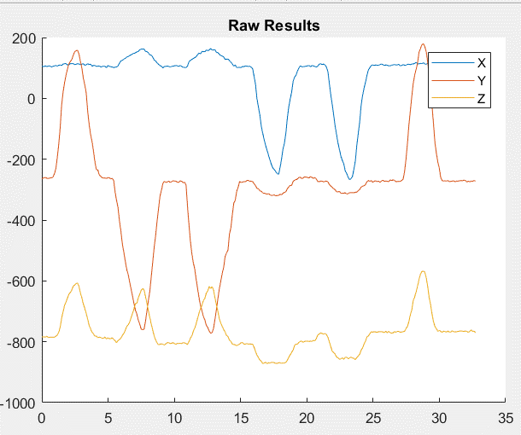

Post Vibe 430